**Assignment 4**

**Mapping Small Reservoirs in West Africa**

**Preparation**

Download W13 data from Brightspace.

With remote sensing, we could capture some special features inside the expected domain. As refer to Landsat 7 bands range.

|  |  |  |  |
| --- | --- | --- | --- |
| Bands | 3 | 4 | 5 |
| Wavelength ($μm$) | 0.63-0.69 | 0.75-0.90 | 1.55-1.75 |

Some features’ reflected wave lengths are shown below.

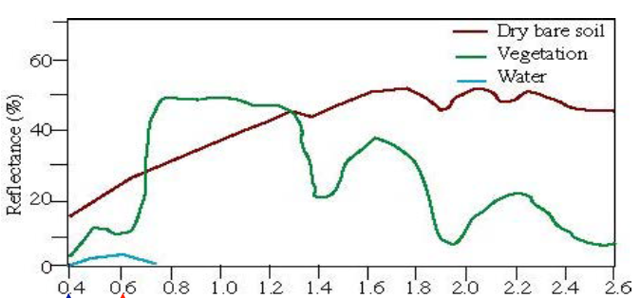

1. Unzip raster data W13 and import band 3,4 and 5 with r.external.

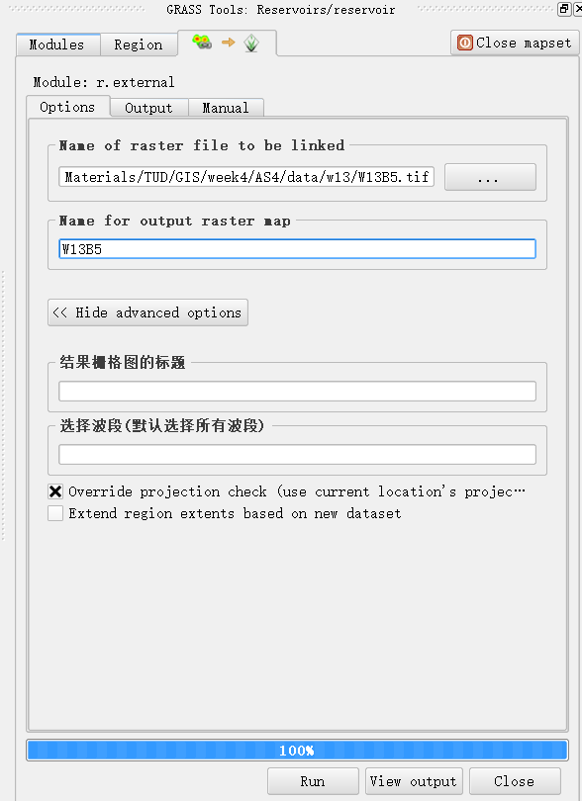

1. Set current region as the same size as imported raster data in the shell.

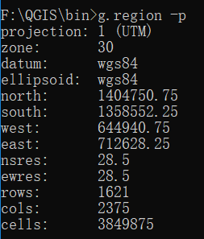

**Q1. Make a map of showing NDVI**

NDVI refers to Normalized Difference Vegetation Index which indicates greens observed in satellite and can be evaluated with the formula below.

$$NDVI=\frac{NIR-Red}{NIR+Red}$$

Where NIR stands for near-infrared regions (band 4) and Red for red band (band 3).

1. Calculate NDVI with raster calculator



1. Using r.color.table to symbolize generated NDVI map and set its color to “Normalized Difference Vegetation Index”.

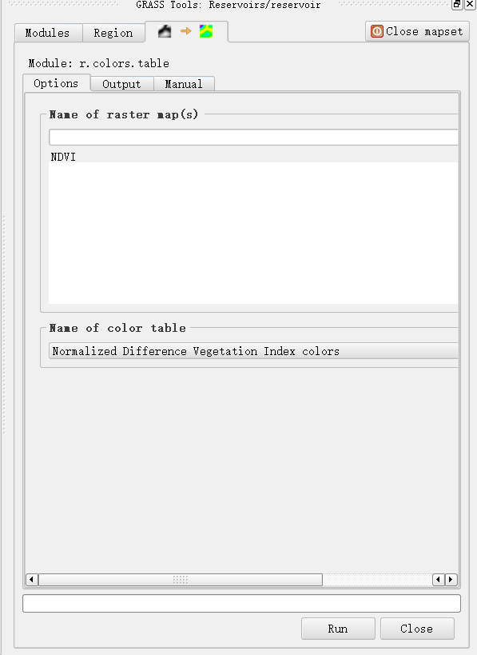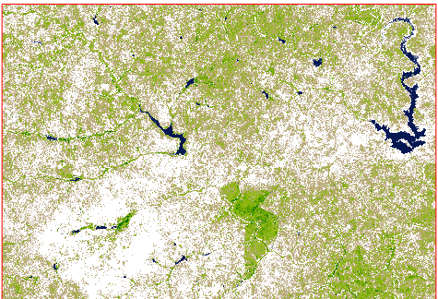

1. Make an NDVI map and annotate this map with highlighting some features that could be identified.

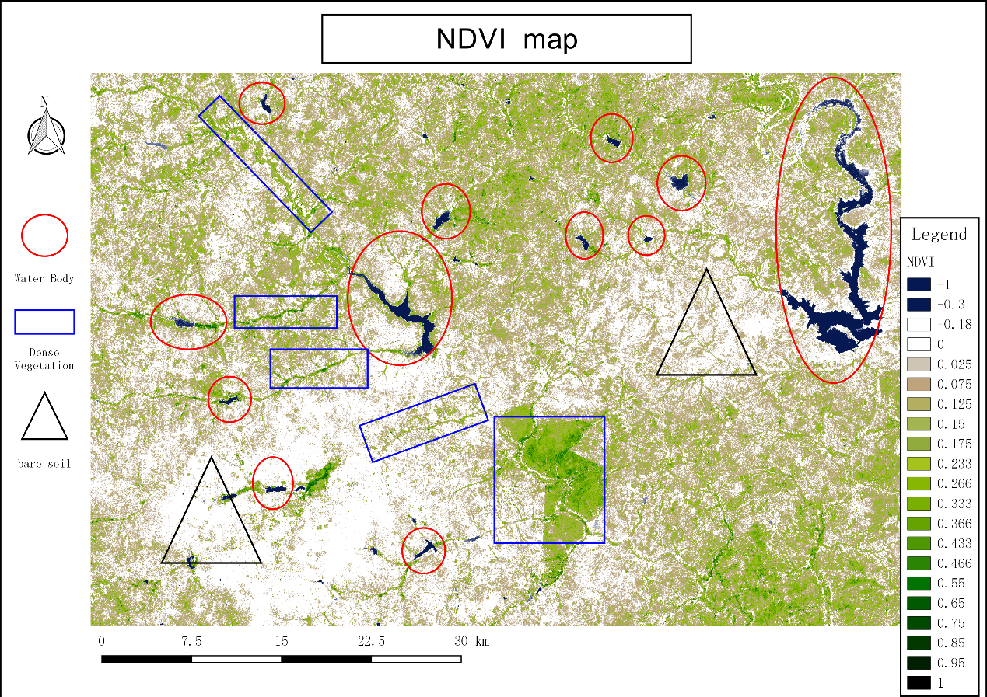

**Q2. Make a false color composite with three bands.**

|  |  |
| --- | --- |
|  |  |
| Red: band 3; Green: band 4; Blue: band 5 | Red: band 4; Green: band 3; Blue: band 5 |
|  |  |
| Red: band 3; Green: band 5; Blue: band 4 | Red: band 4; Green: band 5; Blue: band 3 |
|  |  |
| Red: band 5; Green: band 3; Blue: band 4 | Red: band 5; Green: band 4; Blue: band 3 |

By contrast, we assign band 3, 4 and 5 as blue, red and green respectively to get a better identification and visualization.

Then, the false color map is made including annotating identified features.

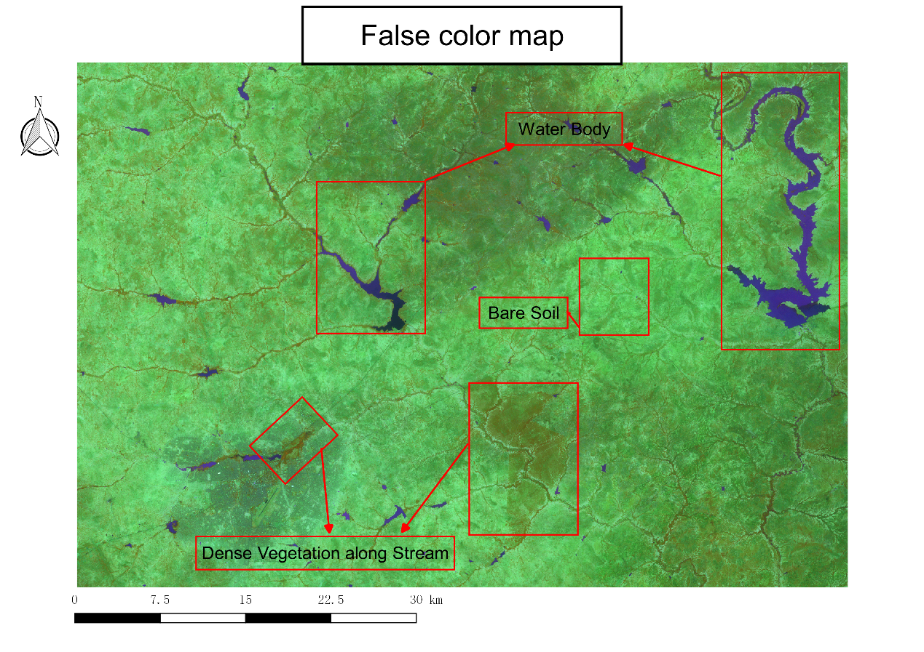

**Q3. Use NDVI and false map composite to make a training map for classification.**

In order to generate training data, we have to draw some polygons to symbolize these features manually so that computer can classify these features inside the whole domain based on these polygons.

1. Add a new shape file and specify different classes as they stand for different features.

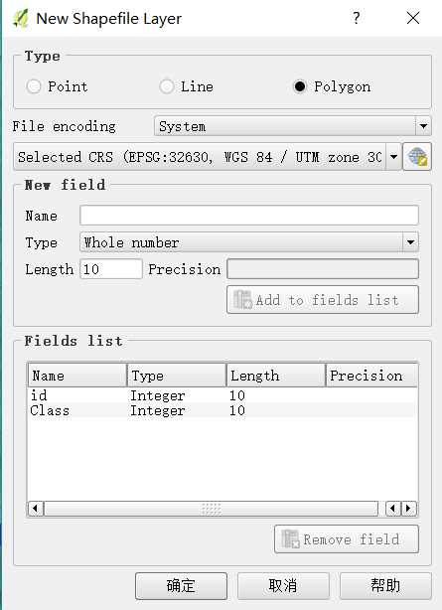

|  |  |  |
| --- | --- | --- |
| **features** | **classes** | **symbol** |
| Water body | 1 |  |
| Dense vegetation | 2 |  |
| Medium vegetation | 3 |  |
| Light vegetation | 4 |  |
| Bare region | 5 |  |
| Urban region | 6 |  |

After this, add training samples to GRASS region with “‘v.in.ogr.qigs’” method.

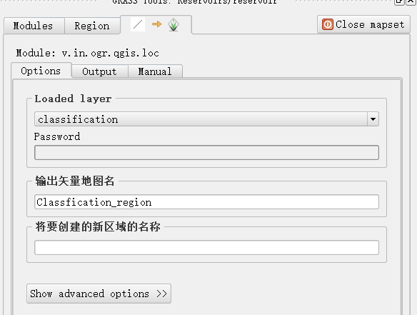

1. Then, convert them to raster data with “v.to.rast.attr” method.

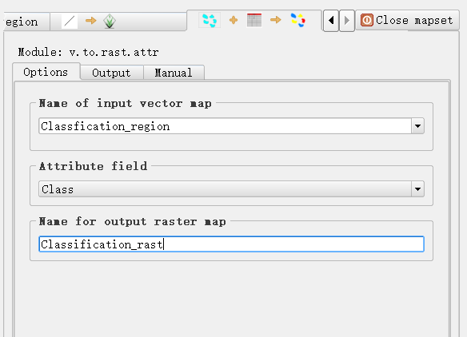

**Q4. Use training map and three bands to perform classification**

1. Before applying classification in GRASS, we need to put three bands together into a group with “i.group” in the shell.

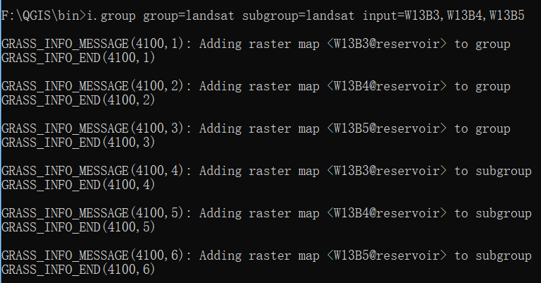

1. Then, we can apply classification method by typing such syntax in the shell.



1. Make a classification map with generated signature file before.



1. With output file, we reset its color map to make it understandable.

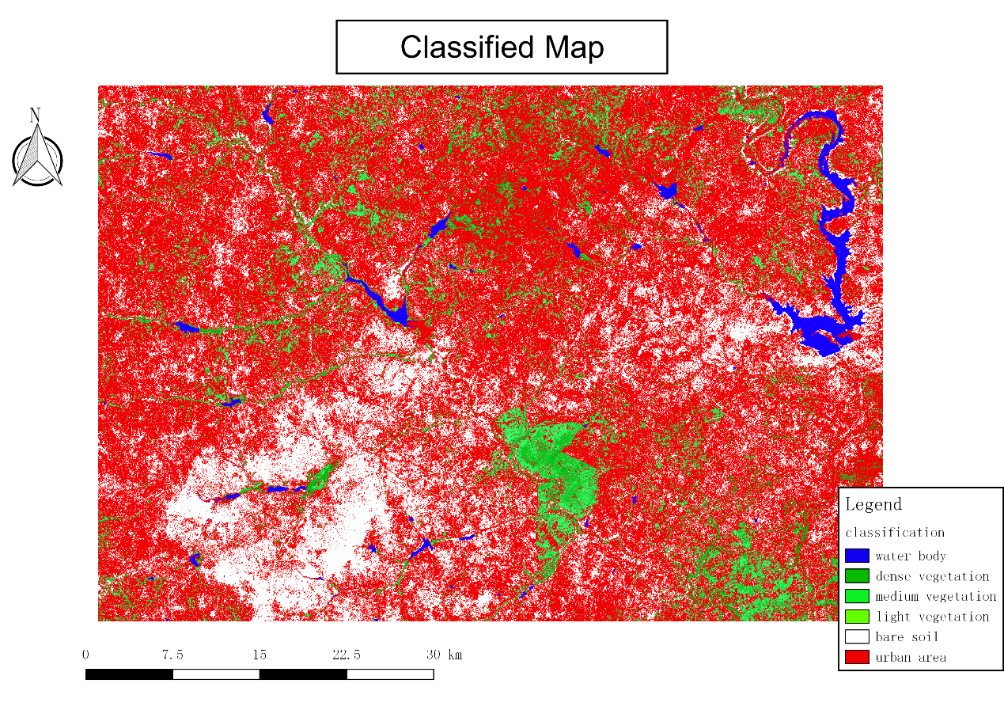

**Q5. Produce a shape file that includes all the water body identified in the classification map. Hand-check whether they are small reservoirs and remove those spurious pixels.**

1. Generate water grids only in the region, “r.mapcalc” is used to make the conditional calculation. Regions with value 1 stand for classified water bodies and the rest should be cleaned since we only focus on water bodies.



The results are given below, we can see only water bodies are left as expected.

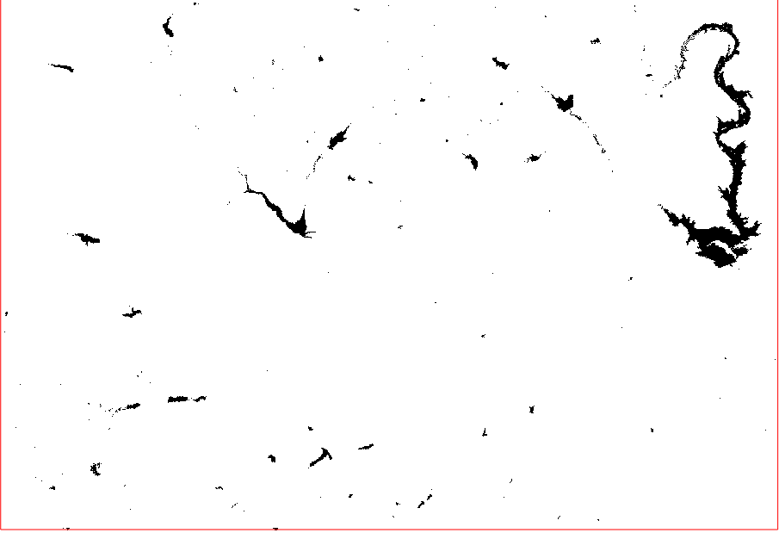

1. Use “r.clump” to group continuous cells into an area with a unique category.

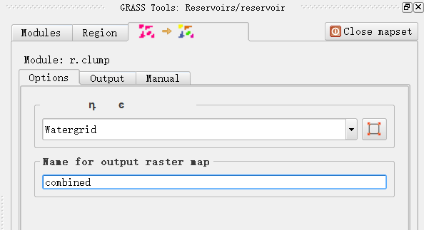

1. Finally, convert raster data to vector data to do hand-check analysis with given reservoirs shape files.

**Before hand checking:**

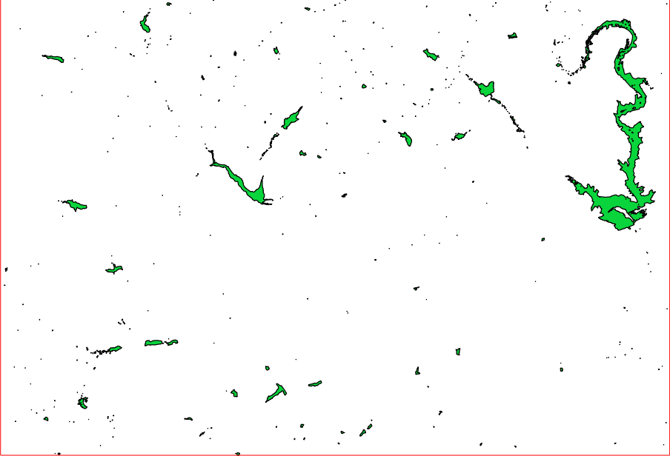

**After hand checking:**

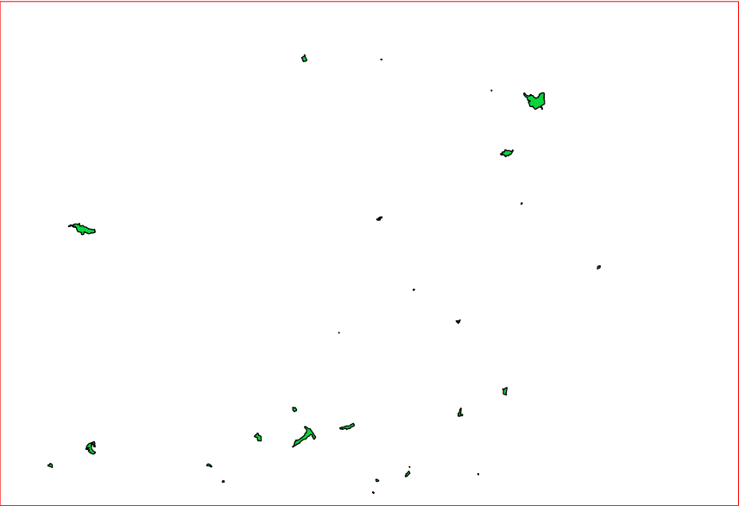

As we see, only a few reservoirs remained eventually because there are a large amount of rivers at the beginning.

**Q6. Calculate the whole areas of small reservoirs and make a histogram of these area values.**

1. Inside attribute table, evaluate areas of each water body with the field calculator and results can be shown in a new column “area”. Note: the units of area are $m^{2}$

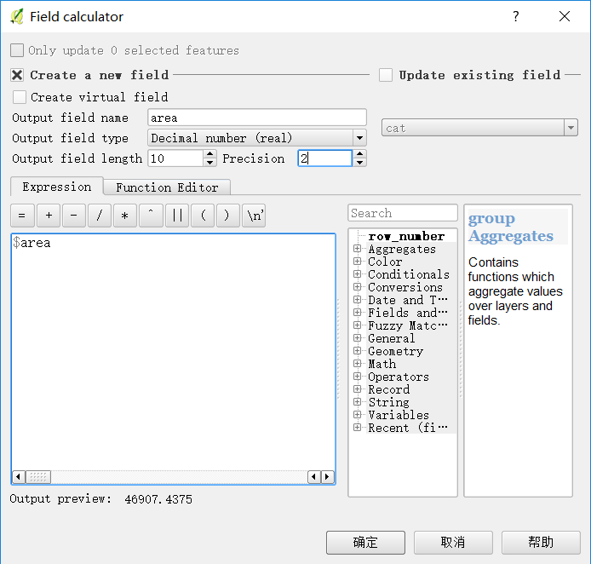 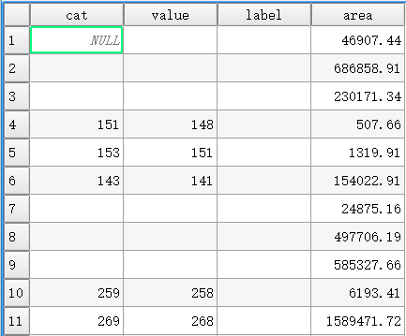

1. Once the calculation is done, export such data into CSV file and import into Matlab to plot a histogram.

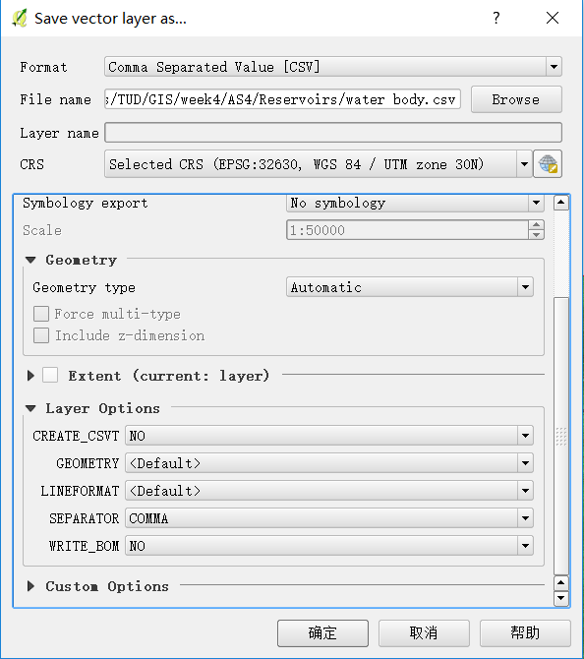

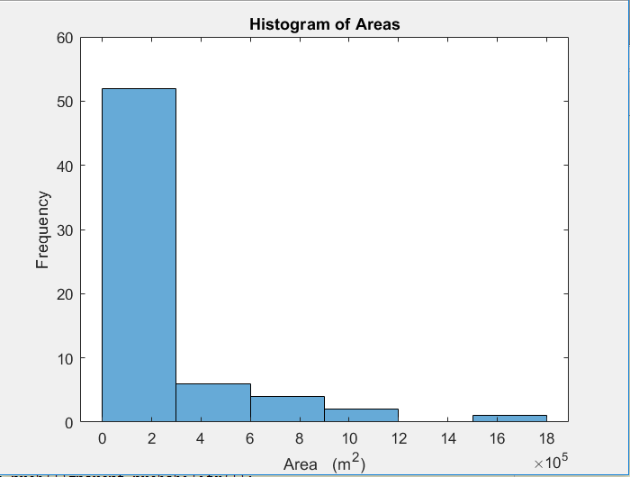

Q7. Calculate the total volume of the water body.

Empirical formulas are utilized to approximate the volume in the area.

$$Volume=0.00857×{Area}^{1.4367} (m^{3})$$

In Matlab, we could simply calculate the volume of each water body and sum them up at last. The result is displayed below.

